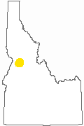 | WIND RIVER OUTFITTERS AREA 01  Operating Area for conducting INCIDENTAL FISHING, TRAILRIDES/ PACK TRIPS activities. Licensed for ELK, DEER, SHEEP, MOOSE, BEAR, COUGAR, PREDATORS, WOLF, CHUKAR, FOREST GROUSE hunting.  View All Operating Areas Licensed by MICHAEL LEROY BRANSON
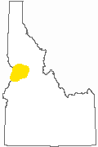 | WIND RIVER OUTFITTERS AREA 02  Operating Area for conducting INCIDENTAL FISHING, TRAILRIDES/ PACK TRIPS, BACKPACKING, PHOTO TRIPS activities.  View All Operating Areas Licensed by MICHAEL LEROY BRANSON
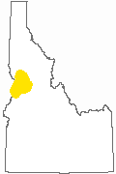 | WIND RIVER OUTFITTERS AREA 03  Operating Area for conducting SNOWMOBILING activities.  View All Operating Areas Licensed by MICHAEL LEROY BRANSON

